Note : all the steps I talk is depend on my knowledge about the data and any mistaks it need to a Business specialization and it was not availaple for me
The steps I took through the project phases :
1- I used Excel to convert the data from csv to excel file c and upload it to MSQL in a data base I created called BrazilianECommerce and uploaded the tables to the database as explained in the screenshot(pic1) and did my data exploration as explained in the file attached caled mege & exploration for more detailes see the file.
Pic1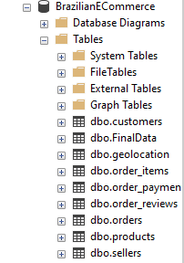
2- The processes I operate on te tables are exest on the file(pic2)
Pic2
After I finished the merge process the final table was :
CREATE TABLE FinalData (
order_id NVARCHAR(50),
order_purchase_timestamp DATETIME,
order_status NVARCHAR(50),
payment_value DECIMAL(10,2),
payment_type NVARCHAR(50),
price DECIMAL(10,2),
freight_value DECIMAL(10,2),
estimated_date DATE,
delivered_date Date,
late_delivary SmallInt );
3-the merged data I select based on the chalenge cratiria I saved on a new file caled selected data
(PIC3)

2- Data Cleaning and correcting All the details you can find in the Jupiter notebook attached

(Pic4)

3- I saved the cleaned data in a csv file called cleaned data Pic 5

4- then the visualization Dashboard in the powerBI file

